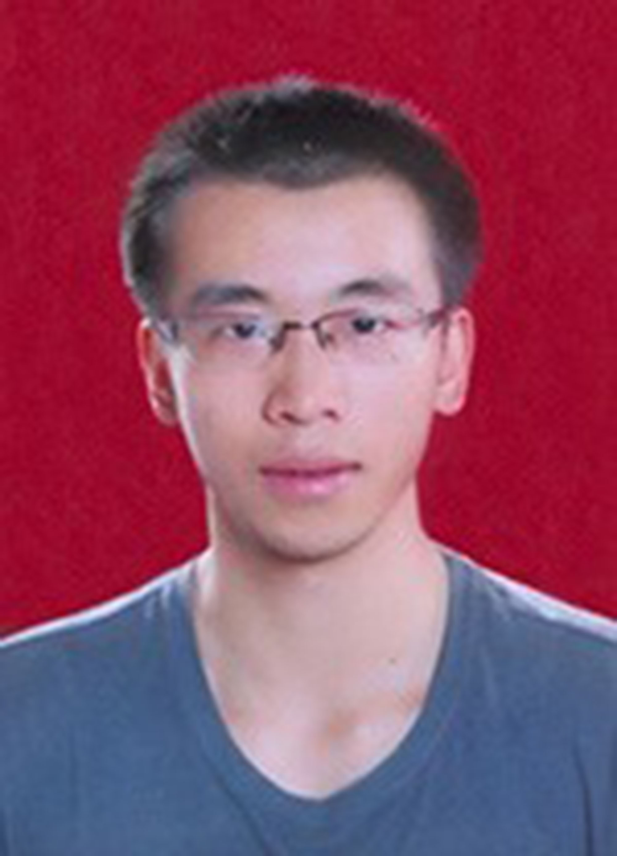
Guan Peng
Email : 875499765@qq.com

Mobile : (+86)17601069526

Address : Zhongguancun Youth Apartment, Beijing City, China
- Eager to learn new technology.
- Good communication and analytical skills.
- Achievement-motivated and a good team player.

EDUCATION
2016 – Present Institute of Computing Technology, Chinese Academy of Sciences, Beijing, China
- Master of Computer Science expected in June 2019 Cumulative GPA: 3.32/4.00
- Concentrations in Web development & Block chain research
2012 – 2016 School of Software Technology, Dalian University of Technology, Dalian, China
- Bachelor of Software Engineering in June 2016 Cumulative GPA: 3.42/4.00
- Courses taken: Data Structure, Computer Network, Computer Architecture, International Finance,
Database, Compiling Principle

PROJECT EXPERIENCES
Nov 17 – Present Lab project, Cloud Platform Management System
- Work : Connected to OpenStack module named Heat. Complete the code of front-end modules. Deploy SaltStack and complete the function of automated maintenance module.
- Tech : Smarty, SVN, SaltStack,
Oct 17 – Present Open source, Teamwork Tools Website named Plate
- Work : Design front-end and back-end separation architecture. Complete the implementation of cross-domain, RESTful APIs and responsive layouts.
- Tech : Express, Flask, Material Design, Git
- Link : Code, Wiki, Website
May – Nov 17 Lab research, Blockchain-based Health Insurance Transfer System
- Work : Use Java web to connect Hyperledger Fabric. Complete the functions of multi-user permissions and medical insurance payment.
- Tech : SpringMVC, Mybatis, Fabric
Jan – May 17 Intern, Beijing Huatourong Company, Web Development
- Work : Develop the official website, including the functions of database design, server maintenance, bids and payments.
- Tech : React, Koa, MySQL

AWARDS / HONORS
2014 Lan Qiao Competition Individual National Second Prize, DLUT
2016 Outstanding graduates of Liaoning Province, DLUT
2017 University of Chinese Academy of Sciences Merit Student, UCAS

ACTIVITIES
2018 – Present Personal Blog
- Design and implement the Hexo theme. Deploy on GitHub Pages.
2015 – Present CSDN Blog and GitBook
- Personal notes and programmatic understanding, about 200 blog posts, with 10W page views.
2017 – Present Github and Gist
- Contain individual or team-completed projects, open source works, learning materials, etc.
2016 – Present Head of Open Source Software Association, UCAS
- Organize open source sharing activities and establish open source learning QQ group.
- Create repository, including GitBook open source recommendations, LeetCode solutions.

SKILLS
Languages Mandarin Chinese (native).
English (CET6). Japanese (N2).
Computer Skills Linux operation.
Java, Python, JavaScript, SQL, etc.

